Simple Closed Curves
In simple closed curves the shapes are closed by line-segments or by a curved line.
Triangle, quadrilateral, circle, etc., are examples of closed curves.
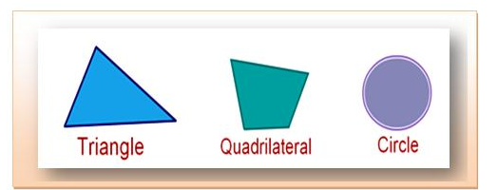
The shape which is not closed by line-segments or a curve is called an open curve
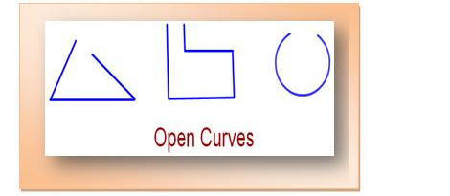.
The curve which crosses itself is not a simple closed curve.

Here is a collection of closed curves. Except curve (d) and (e), the remaining shapes are simple closed curves.
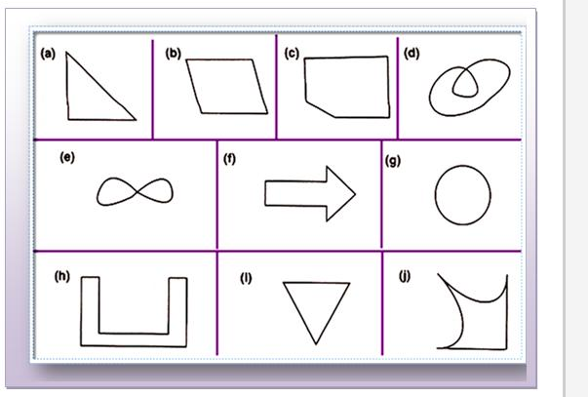
Some simple closed curves are made of line-segments only. These curves are known as polygons. Triangle, quadrilateral, pentagon etc., are polygons.
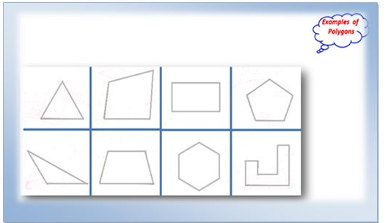
Different Types of Polygons

The triangle has 3 sides and 3 vertices.
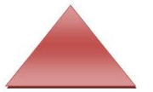
The quadrilateral has 4 sides and 4 vertices.
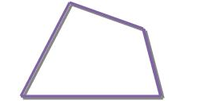
The pentagon has 5 sides and 5 vertices.
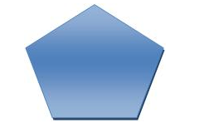
The hexagon has 6 sides and 6 vertices.

